Tools

-----------

To edit and write code you will need a code editor, there are plenty of them but I recommend Sublime Text -> <https://www.sublimetext.com/3>

The core of the project is Cordova, that compile your code for multiple platforms as Android or iOS from web languages. You can download it here <https://cordova.apache.org/> and find some tutorials to install it.

To design the application you will need to use CSS but not in the normal way. To give the code lighter and easy understandable, I use SCSS.  
It uses a Ruby compiler and compass plugin to compile your SCSS code into CSS, but it’s really good to use when you have a lot of HTML to manipulate.

Before starting, know more about SCSS itself : https://www.sitepoint.com/whats-difference-sass-scss/

Then you can install the needed stuff : <http://thesassway.com/beginner/getting-started-with-sass-and-compass>

As you develop a web application in a first time, you will debug it into your favorite browser. First you need to host locally the application, so you can use either WAMP (<http://www.wampserver.com/>) or other stuff.  
  
As you will have to use Google Chrome, I recommend to use a light Chrome Plugin to host the application Web Server for Chrome : <https://chrome.google.com/webstore/detail/web-server-for-chrome/ofhbbkphhbklhfoeikjpcbhemlocgigb>

Finally, install Ripple, that is a mobile emulator for browser. It is an essential plugin to develop using Cordova : <https://chrome.google.com/webstore/detail/ripple-emulator-beta/geelfhphabnejjhdalkjhgipohgpdnoc>

Application structure

-----------

First of all, you can find a full diagram of the application structure here : TODO LINK

Now I will explain you how to understand the application :

You have three main features in the application :

* Information
* Newsfeed & event search
* Map & Interest points

VIEW & CONTROLLER

To navigate between each of those tabs, we use the AngularJS controllers. I recommend you to get some knowledge by following tutorials before starting coding. So each time you click on one of those tab, you will call an html file that calls a controller itself. So the html file is the face of the page, and the controller regroup all the action called by the HTML page. Because yes, one of the power of AngularJS is to access and modify variables available in the controllers directly from the HTML code.

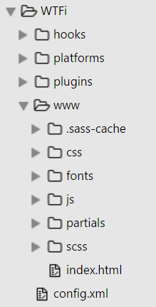The controllers are in JavaScript files under JS folder and HTML files under partials folder except for the main page ‘index.html’ that is at the root.

Example :

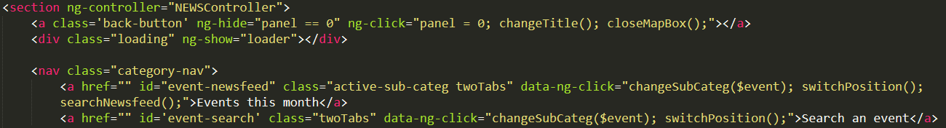

First you indicate the NEWSController in the HTML tag at the place you want, you will be able to use it inside it. Here is in the section for example. Then we can call some methods as in the <a href> with data-ng-click property or even variables as below.

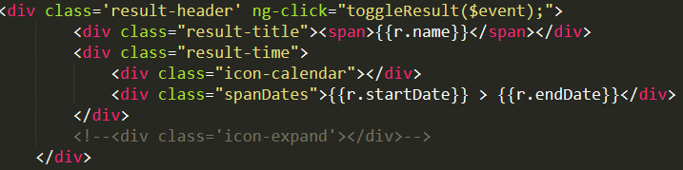

We use variables defined as $scope.name in the controller and retrieve here using {{r.name}}. Quick to display results and so on.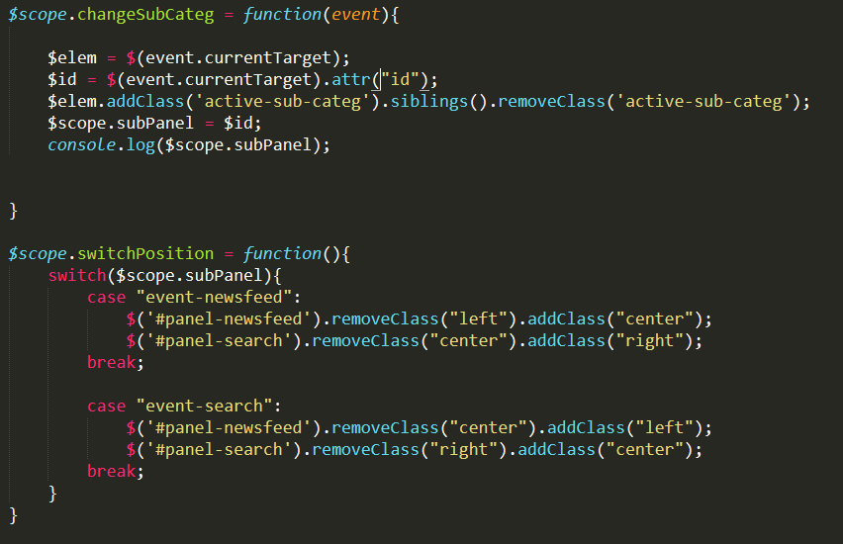

Here are the methods we call from the data-ng-click property in HTML.  
  
So as you can see we can make simple relations between the view and the controller(actions). This system is implemented for a lot of HTML files if they need to display non-static data.

APIS USED

To avoid problems using asynchronous ajax calls, all the ajax methods are stored in services that are available in the main JS file of the application : app.js  
  
Here you can find few settings for the HTTP / HTTPS request and mostly the services to retrieve data from API. With this way we can avoid the infinite ajax calls loop that make the application crashing.

The application consume multiple APIS, all quite simple to use.

HRI : Linked events API

Original link : <http://www.hri.fi/fi/dataset/linked-events-tapahtumarajapinta>

Better explainations and example of uses : https://dev.hel.fi/projects/linked-events/

This API is provided by HRI, so all data are opened and free to use.

This API is used to retrieve all data related to the events happening in the Helsinki region. We pass dates in parameters and optionally few words of what we are looking for to sort the results.

Example :

url = "https://api.hel.fi/linkedevents/v1/event/?start=" + start +"&end=" + end;

Then we analyze the returned JSON arrays.

YANDEX : Translate API

We met a problem : most of the events description provided by HRI are in finish. The application is designed to be used by Exchange Students mainly, so we need to give it in English.  
  
The Yandex Translate API is really easy to use, reactive and free to use.

Just pass the description and it’s ok as you can see below :

url = "https://translate.yandex.net/api/v1.5/tr.json/translate?key=trnsl.1.1.20161010T081456Z.bda15500146481fc.fee8488de72809ff7c6acffab1492498031cb1b2&text="+textToTranslate+"&lang=fi-en";

Then we analyze the returned JSON arrays.

GOOGLE : MAPS API

For the map tab, we implemented the map provided by google maps. To avoid problems with mobile OS and security failures, the chosen way is the embed API using an <iframe> htlm. The easiest and fastest way to use this API. To modify the content displayed, we need to modify the source of the iframe that corresponds to a normal searching URL on Google Maps Website.

DESIGN

CHART DESIGN

As it is a web application and not a native application, we can use and mix designs trends and guidelines as much as we want.

First, we use the Flat Design guidelines for the main structure. If you don’t know what the Flat Design is, go there :

* https://gizmodo.com/what-is-flat-design-508963228

We also use Google design guidelines : Material Design (<https://material.google.com/>)

To implement it in the web application, we use materializecss that is a css library which imitates the native Material Design when developing in Android.

* <http://materializecss.com/>

All the chosen colors and fonts are used in Flat Design.

The main fonts are Montserrat and Lato.

The Flat Design icons come from <http://www.flaticon.com/>

DESIGN STRUCTURE

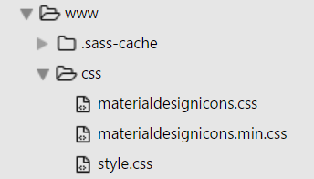You have first non-compiled css sheets. If you find some css sheets to use, put it there.

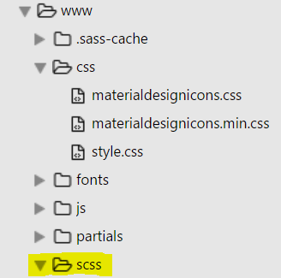If you want to use SCSS sheets, you will need your Ruby / Compass compiler, all the files will be compiled in the following structure.

Folders :

Sass : all your original SASS sheets should be there

css : then they will be compiled into css sheets that will be there

fonts : to keep the fonts available on mobile, put them there

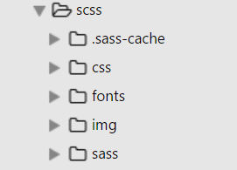img : even for the images, put them here, even if it can be weird. Otherwise, once you compile the application, all the images / icons stored in another folder won’t be find anymore.

SLIDING

To make the slides animation, I use some function in the controllers that detects on what we clicked, and then add or remove functions like right, center, left that are composed of animation. Just have a look, it is easy to use as it’s just a class to add in html.

Here is the switchPosition() method that is in ng-click of HTML tag you want to move.

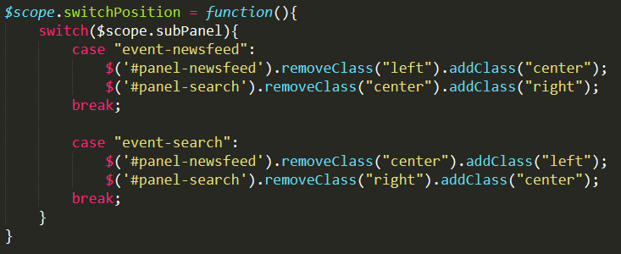

For the events tabs.

DEBUG & ADVICES

To debug the app, use console.log and the networks tool under the dev console in browser.

If you have some problems loading a script, iframe are whatever, check about the Content Security Policy and the frame blocked by certain browser.

Do not only develop in the web browser, try to compile it on your phone as often as you can, you will have some changes and surprises.

Thanks for following my technical specifications.